**Car Rental System**

**1. System Overview**

The crux of the project is to build a CLI that helps in automating the renting process. This system requires no manual paperwork which enhances efficiency while reducing the chances of human errors. This system is built with role based access, thus enabling the administrators to manage cars and bookings whereas the customers can only view the available cars and make reservations.

**2. Use Case Diagram**

**3. Class Diagram**

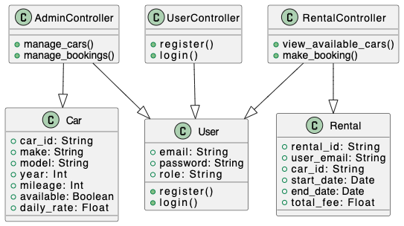

**4. Sequence Diagram - User Registration**

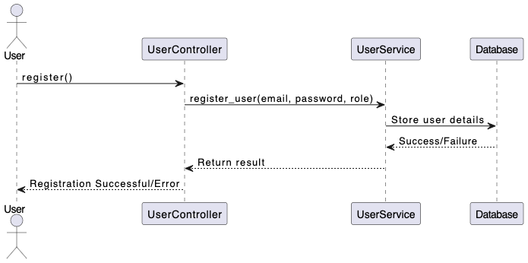

**5. Sequence Diagram - Car Booking**

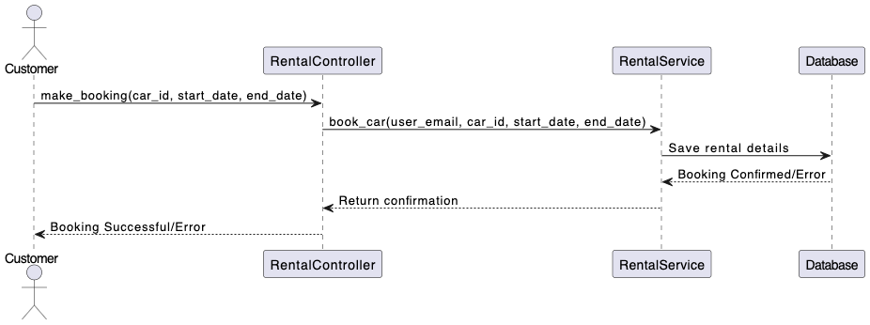

**6. Design Patterns Used**

**Singleton Pattern:**

* Used in DatabaseConnection to ensure a single connection instance for MongoDB.

**7. Software Evolution Plan**

To ensure long-term scalability and maintainability, we will follow a structured evolution plan:

**Versioning Strategy**

* Semantic Versioning (v1.0.0, v1.1.0, v2.0.0).
* Release patch updates for minor bug fixes.
* Introduce major releases when adding new features.

**Maintenance Strategy**

* Use unit testing to prevent regressions.
* Automate testing with PyTest.
* Implement code linting (Flake8, Black) for consistency.

**Backward Compatibility Plan**

* Ensure database migrations are handled smoothly.
* Use feature toggles to enable/disable new features gradually.
* Maintain API contracts to avoid breaking changes in future updates.

### **Innovative Feature Proposal: AI-Based Car Recommendations**

**Overview:**  
The objective is to enhance our car rental service’s offering through differentiating it with an AI-Based feature that identifies the most suitable cars for the customer. The feature will improve customer experience by recommending the most relevant cars based upon clients unique rental history and behaviors.

**How It Works:**

* The company's system captures customer booking patterns, including types of cars booked, frequency and length of bookings.
* A recommendation engine will use this information to choose cars that the user would be interested in renting.
* These suggestions will be shown in a special section called “Recommended for You ” when customers log into their account.

**Benefits:**  
 Custom Approach: Clients that have previously booked specific car models will quickly and easily buy the right car.

✔ Improved Customer Retention: Helps encourage repeat rentals by facilitating personal tailored suggestions.

✔ Differentiated Marketing Strategy: Advanced user experience with complements to primitive rental systems, diagnosing simple problems with complex solutions.

Including AI with this feature will provide a new competitive edge against all other pre-existing recommendations making the car rental business smarter when compared to the old way of doing things.